Assignment Test 2, 2015

Question/Answer Booklet

CHEMISTRY 3AB
Total marks:

/25

Student name: _____________________________________________

Teacher: _____________________________________________
Methanol Synthesis
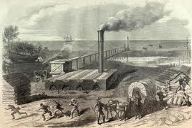
Methanol is the simplest of all alcohols and has a wide application range. The global annual production was approximately 38million metric tons in 2007 and is expected to grow in the near future.

Methanol is produced from ‘syngas’ - a mixture of H₂, CO, and minor quantities of CO₂and CH₄.

1. Write a balanced chemical equation for the equilibrium reaction between hydrogen gas and carbon monoxide gas to form methanol (CH₃OH) vapour.

Equation: 2 H_{2 (g)} + CO_{(g)} → CH₃OH_{(g)}
(1 mark)

In large-scale methanol production plants, the typical temperature range for methanol making is 200-300° C. The reaction to form methanol is strongly exothermic, and efficient heat removal is a problem.

If the temperature is too high, the catalyst breaks down and unwanted by-products such as ethanol and methyl formate are produced.

Efficient temperature control is thus necessary to reduce by-product formation and to ensure the catalyst works properly.

Reducing the operating temperature is a possible option but catalytic activity is poor at low temperature.

A new copper-based catalyst that works at lower temperatures and allows a lower operating pressure of about 500kPa has been developed and used in modern plants.

2. Theoretically, what temperature and pressure conditions would increase the rate of this process? Write your answer as high or low. (1 mark)

Temperature: HIGH Pressure: HIGH

3. Theoretically, what temperature and pressure conditions would increase the equilibrium yield of this process? Write your answer as high or low (1 mark)

Temperature: LOW Pressure: HIGH

4. What conflict exists (if any) between rate and yield considerations and how is this conflict resolved in practice? (2 marks)

A high temperature increases rate but lowers yield

Temperature of 200 – 300ºC is a compromise between rate and equilibrium

The following information is relevant for Questions 5 and 6

Case Study 1: A new owner of an industrial methanol synthesis plant decides to adjust a few existing temperature and pressure settings to improve methanol production output. The graph below shows the concentration of all three (3) gases before and after the change was made to the equilibrium system.

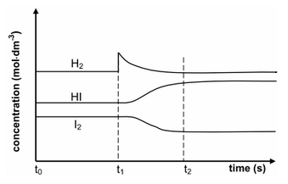
CH₃OH
H₂
CO

5. What change to the equilibrium system was made at t₁? Explain your answer using Le Chatelier’s principle. (3 marks)

The concentration of H_{2(g)} was increased.

This is indicated by the sharp increase in [H₂] at t₁.

[CH₃OH] increases after this change and [CO] decreases indicating a favouring of the forward reaction pathway to counteract the increase in [H₂] in the equilibrium reaction

6. Some time after t₂ (see graph), the new owner increases the volume of the reacting chamber. Use the axes below to show the resultant effect (if any) to the concentration of CO and CH₃OH.

concentration

CH₃OH

CO

time

instant where volume is increased (2 marks)

Encouraged by the findings, the owner purchased an ‘Magic Equilibrium Booster’ from eBay and added it to the reaction mixture at equilibrium. Unfortunately, the compound poisons the catalyst and stops it working.

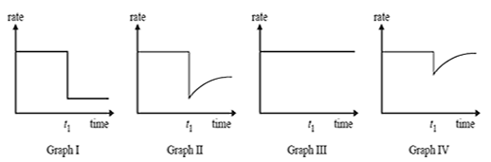

7. (a) Which of the graphs above best represents the change in rate of the reverse reaction over time due to this unfortunate event? (1 mark)

- Graph 1
- Graph 2
- Graph 3
- Graph 4

Answer: A

(b) Briefly explain how catalysts affects reaction rate and use this to explain your answer to part (a).
(3 marks)

Catalyst speeds up the rate of reaction by lowering E_{A} enabling more reactant molecules to form products (1) – hence the immediate decrease after the death of the catalyst at time t₁ (1)

Catalyst does not affect equilibrium hence there is no change in the rate of the reverse reaction after time t₁ (1)

The use of copper catalyst in the synthesis of methanol also catalyses two (2) other chemical reactions,

- the Water Gas Shift (WGS) reaction, CO_{(g)}+H₂O_{(g)} CO_{2 (g)} +H_{2 (g)}
and
- the Reverse Water Gas Shift (RWGS) reaction, CO_{2 (g)} +H_{2 (g)} CO_{(g)}+H₂O_{(g)}.

The Reverse Water Gas Shift (RWGS) reaction only occurs at high temperatures and pressures. The following diagram shows the relationship between temperature and equilibrium yield at various pressure settings.

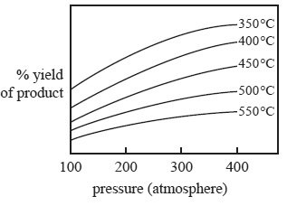

8. Which of the following best describes the Reverse Water Gas Shift reaction? (1 mark)

- The reaction is exothermic because the yield increases as the temperature increases.
- The reaction is endothermic because the yield increases as the temperature increases.
- The reaction is exothermic because the yield decreases as the temperature increases.
- The reaction is endothermic because the yield decreases as the temperature increases.

Answer: C
9. Use the information concerning the Reverse Water Gas Shift reaction to sketch an energy profile diagram for the reaction. Clearly label:

- both axes
- Activation Energy (E_{a})
- Heat of reaction (ΔH)

Catalytic substances such as nickel and copper metals are often used in this reaction. Draw a possible catalysed pathway on the same graph. (4 marks)

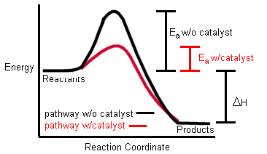

An alternative method of methanol synthesis is the equilibrium reaction between carbon dioxide and hydrogen gas.

3H_{2 (g)} + CO_{2 (g)} CH₃OH_{(g)}+ H₂O_{(g)}

10. Write an equilibrium expression (K_{eq}) for the reaction above. (1 mark)

K = [H₂O] × [CH₃OH]
[H₂]³ × [CO₂]

11. What effect (if any) would the use of a suitable catalyst have on the value of K_{eq} for the reaction above?
(1 mark)
No effect

12. For the equilibrium reaction
3H_{2 (g)} + CO_{2 (g)} CH₃OH_{(g)}+ H₂O_{(g)}

(a) Predict whether the following changes will increase, decrease or have no effect to the rate of the forward reaction.

Change | Effect
More gaseous water is added | INCREASE
The pressure of H₂ is increased | INCREASE

(b) Predict whether the following changes will increase, decrease or have no effect on the equilibrium yield of the reaction

Change | Effect on yield
Helium gas is added to the system | NO EFFECT
Decreasing the volume of the system | INCREASE
(4 marks)

END OF TEST

